NAME :: UTKARSH TIWARI

INTERN ID: 200144

POSTGRESQL ASSIGNMENT

DPhone corporation is telecommunications industry wants to develop software for there new upcoming phone. They came to your company. You as team member have responsibility to develop this standalone application. They having following requirements.

1.User can register and login

2. User can give referral for phone from their family or friends.

3. If user referral buy mobile the user will get 1000 bonus points. 1point is equal to 1Rs.

4. User can view referral, edit referral, delete referral.

In this you as team member have to design database.

Create following tables

User(userId,first name,last name, address, mobile, email, username, password)

Referral( referalId, referral First name, referral last name, mobile, email, userId(fk), date of referral, referral points, status)

Customer(custermerId, first name, last name, email, mobile)

BuyingDetails( custermerId(fk),userId,purchase date, productName)

Insert 5 records in each table and write Sqlqueries for following operations.

CREATE TABLE users (userId INT PRIMARY KEY, fname TEXT NOT NULL, lname TEXT

, m_no TEXT [], email TEXT, user_name TEXT UNIQUE,password TEXT NOT NULL);

CREATE TABLE referral(ref_id INT PRIMARY KEY, ref_fname TEXT NOT NULL, ref_lname TEXT, m_no TEXT [],email TEXT, userid INT, dt_of_rfl DATE NOT NULL, rfl_pts INT, status TEXT, CONSTRAINT fk_userid FOREIGN KEY(userid) REFERENCES users(userid));

CREATE TABLE customer(cust_id INT PRIMARY KEY, cfname TEXT NOT NULL, clname TEXT NOT NULL, email TEXT, mobile TEXT [] );

CREATE TABLE buy_dtls(cust_id INT PRIMARY KEY, userid INT, purchase_date DATE NOT NULL, pdt_name TEXT NOT NULL, FOREIGN KEY(cust_id) REFERENCES customer(cust_id), FOREIGN KEY(userid) REFERENCES users(userid));

INSERING THE VALUES::

INSERT into users(userid, fname, lname, m_no, email, user_name, password) values (101, 'Utkarsh', 'Tiwari',ARRAY['9109192102'],'uttiwari@gmail','_utkarsh.t','Utk@rsh'), (102,'Yashvi','Tiwari', ARRAY['8939149591'],'yttiwari@yahoo','ytiw_ari','Yashv!'),(103,'Anisha','Sharma',ARRAY['8977676771'],'anishinf@gmail','anisharma','@anishrma'),(104,'Devesh','Gupta',ARRAY['8889855155'],'dev@gmail','Dev_sh','gupt@45'),(105,'Kshitij','Kumar',ARRAY['7999915789'],'kkumar@gmail','k_kumar18','Kum@r57');

INSERT INTO referral values(2301,'Abhishom','Bhatacharya',ARRAY['3457788'],'abhi@gmail',101,'2023-01-03','1000','Excepted');

INSERT 0 1

ut=# DELETE from referral;

DELETE 1

ut=# INSERT INTO referral values(2301,'Abhishom','Bhatacharya',ARRAY['3457788'],'abhi@gmail',101,'2023-01-03',1000,'Excepted');

INSERT INTO referral values(2302,'Sudarshan','Banerjee',ARRAY['915099'],'sudha@gmail',101,'2023-01-04',0,'Pending');

INSERT INTO referral values(2303,'Rajeeta','Sarkar',ARRAY['787333'],'vipul@gmail',102,'2022-09-21',1000,'Excepted');

INSERT INTO referral values(2304,'Vipul','Choubey',ARRAY['789901'],'suk@gmail',103,'2022-11-22',0,'Pending');

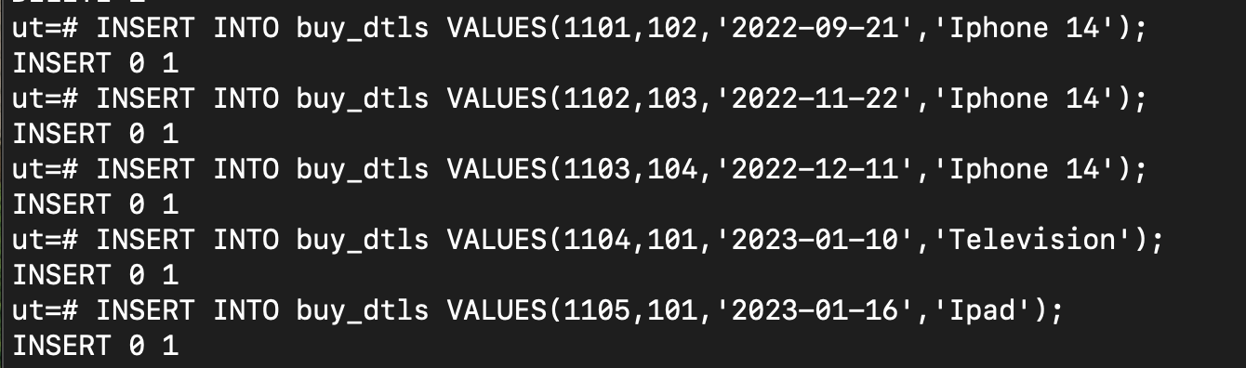

1. Display total number of referral done by particular user by userId.

SELECT userid, COUNT(userid) from referral GROUP BY userid;

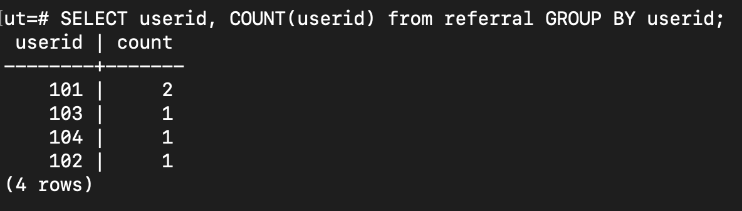

1. Display total number of points earned by user.

SELECT userid, COUNT(userid),SUM(rfl_pts) from referral GROUP BY userid;

1. Display name and mobile of user whose referral customer have purchased item on 21/09/2022

SELECT fname,lname,m_no FROM users u INNER JOIN buy_dtls b ON (u.userid=b.userid AND b.purchase_date='2022-09-21');

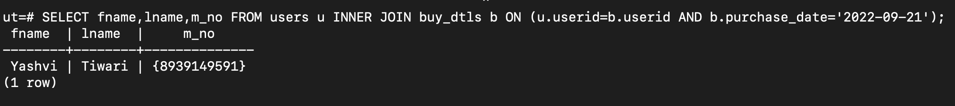

4.Display details of customer who purchased “iPhone 14”

SELECT c.* FROM customer c INNER JOIN buy_dtls b ON (c.cust_id=b.cust_id AND b.pdt_name='Iphone 14');

OR

SELECT c.cust_id, c.cfname, c.clname, c.email, c.mobile FROM customer c INNER JOIN buy_dtls b ON (c.c

ust_id=b.cust_id AND b.pdt_name='Iphone 14');

5.delete all record of customer including purchase details Those have purchased iPhone 14.

BEFORE writing the below query we have to alter the foreign key that connects buy_dtls table and the customer table(we need to add ON CASCADE)

ALTER TABLE buy_dtls DROP CONSTRAINT buy_dtls_cust_id_fkey;

ALTER TABLE buy_dtls ADD CONSTRAINT bdt_cust_id_fkey FOREIGN KEY(cust_id) REFERENCES customer(cust_id) ON DELETE CASCADE;

DELETE FROM CUSTOMER WHERE cust_id IN(SELECT c.cust_id FROM customer c,buy_dtls b WHERE (c.cust_id=b.cust_id AND b.pdt_name='Iphone 14'));

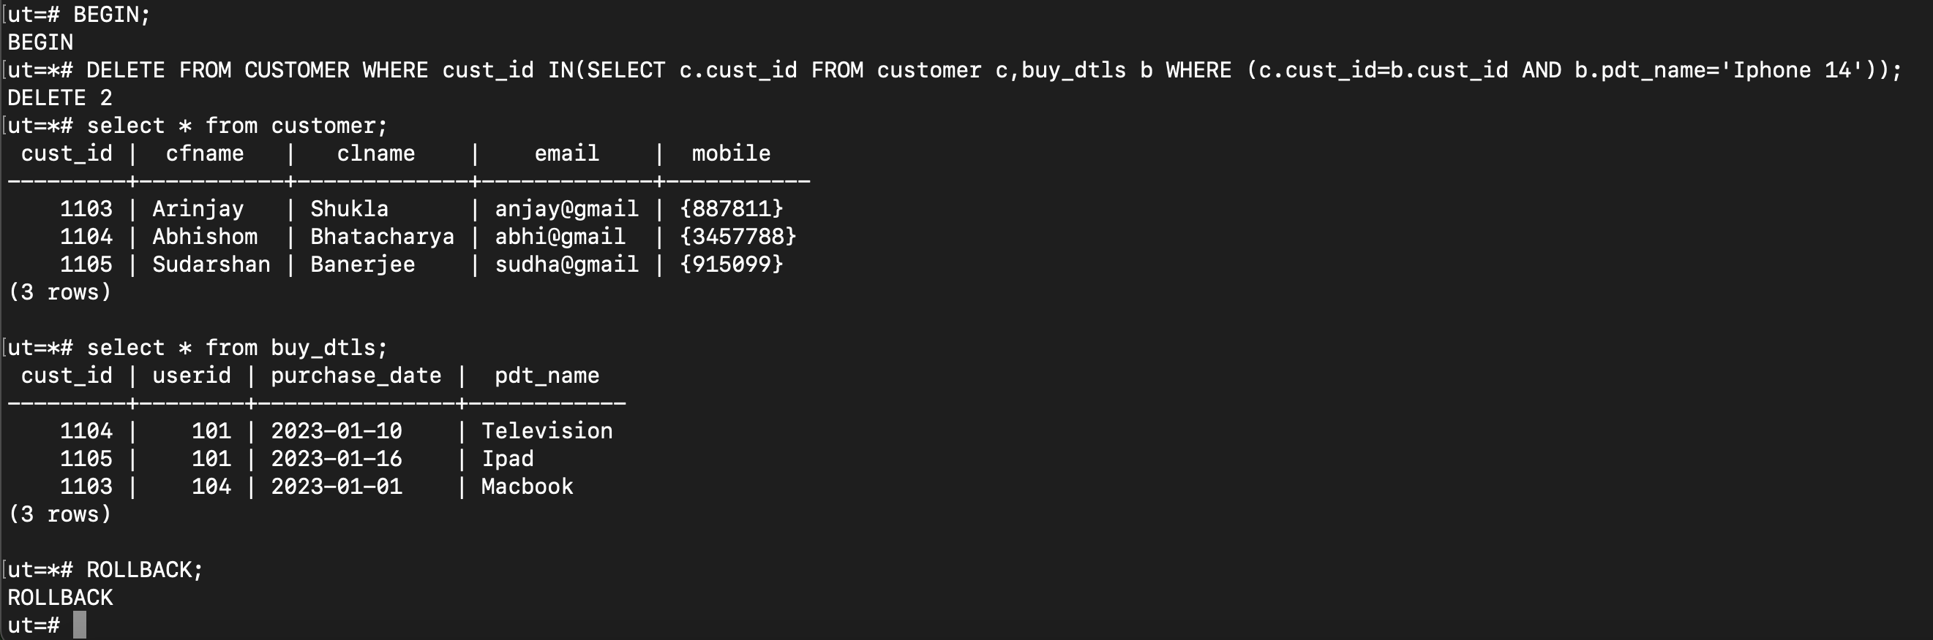

15. Write userview to display only first name, last name, mobile and email. And

Perform following queries on view

-Display record by email

-Display record by mobile

CREATE VIEW userview AS SELECT fname, lname,m_no,email FROM users ORDER BY email;

CREATE VIEW userview2 AS SELECT fname, lname,m_no,email FROM users ORDER BY m_no;



